Title: “Intelligent Ultrasound”

Abstract:
User dependence is one of the main challenges of ultrasound diagnosis. Specifically, both acquisition of the standard plane and measurement of biometric parameters are crucial for medical ultrasound diagnosis. However, these processes require substantial experience and a thorough knowledge of human anatomy. This talk will introduce our recently developed machine learning algorithms for automating standard plane detection and biometry measurement in ultrasound. Our developed learning algorithms include random forest, convolutional neural network, recurrent neural network and spatio-temporal regression. All these projects were carried out jointly with local hospitals and companies in Shenzhen, Guangzhou and Hong Kong. Some of them are being commercialized.

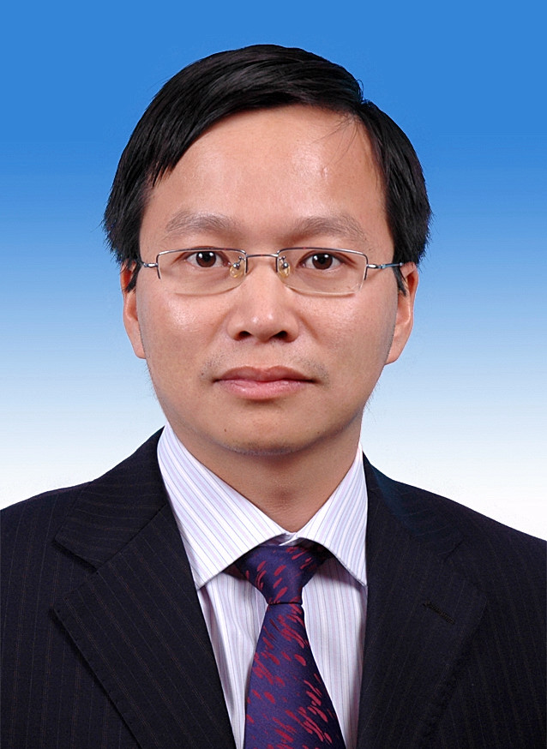

Dong Ni is an associate professor of School of Biomedical Engineering in Shenzhen University, China. He is currently the associate dean of School of Biomedical Engineering. Dr. Ni received his BSc and MSc (Biomedical Engineering) from Southeast University, China. He received his PhD (Computer Science) from the Chinese University of Hong Kong. After PhD, he worked as a postdoctoral research fellow in University of North Carolina at Chapel Hill, USA. Dr. Ni’s research interests include medical ultrasound image analysis, machine learning, and virtual reality.

